REPOUSING REPORT NG

Download the below dependencies from maven repository

**Pom.xml FILE**

<!--repoprt using reportNg dependencies-->

<!--ReportNg 1.1.4-->

<dependency>

<groupId>org.uncommons</groupId>

<artifactId>reportng</artifactId>

<version>1.1.4</version>

<scope>test</scope>

</dependency>

<!--Velocity-dep 1.4-->

<dependency>

<groupId>velocity</groupId>

<artifactId>velocity-dep</artifactId>

<version>1.4</version>

</dependency>

<!--Guice 3.0-->

<dependency>

<groupId>com.google.inject</groupId>

<artifactId>guice</artifactId>

<version>3.0</version>

</dependency>

Goto>project>rightclick>properties>testng>

Check the checkbox: disable default listener

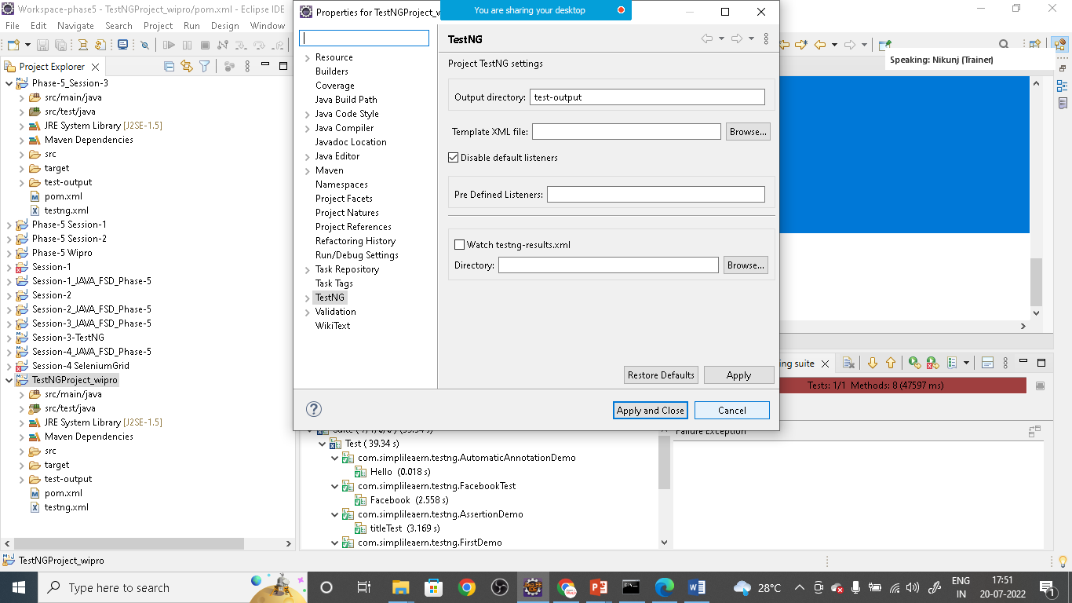

Click on apply and apply and close

**Goto> Testng.xml file and add the below Listners**

<?xml version=*"1.0"* encoding=*"UTF-8"*?>

<!DOCTYPE suite SYSTEM "https://testng.org/testng-1.0.dtd">

<suite name=*"Suite"*>

<listeners >

<listener class-name=*"org.uncommons.reportng.HTMLReporter"*></listener>

<listener class-name=*"org.uncommons.reportng.JUnitXMLReporter"*></listener>

</listeners>

<test thread-count=*"5"* name=*"Test"*>

<classes>

<class name=*"com.simplileaern.testng.AutomaticAnnotationDemo"*/>

<class name=*"com.simplileaern.testng.FacebookTest"*/>

<class name=*"com.simplileaern.testng.AssertionDemo"*/>

<class name=*"com.simplileaern.testng.FirstDemo"*/>

<class name=*"com.simplileaern.testng.GroupTest"*/>

</classes>

</test> <!-- Test -->

</suite> <!-- Suite -->

Goto> your project>maven> update the project

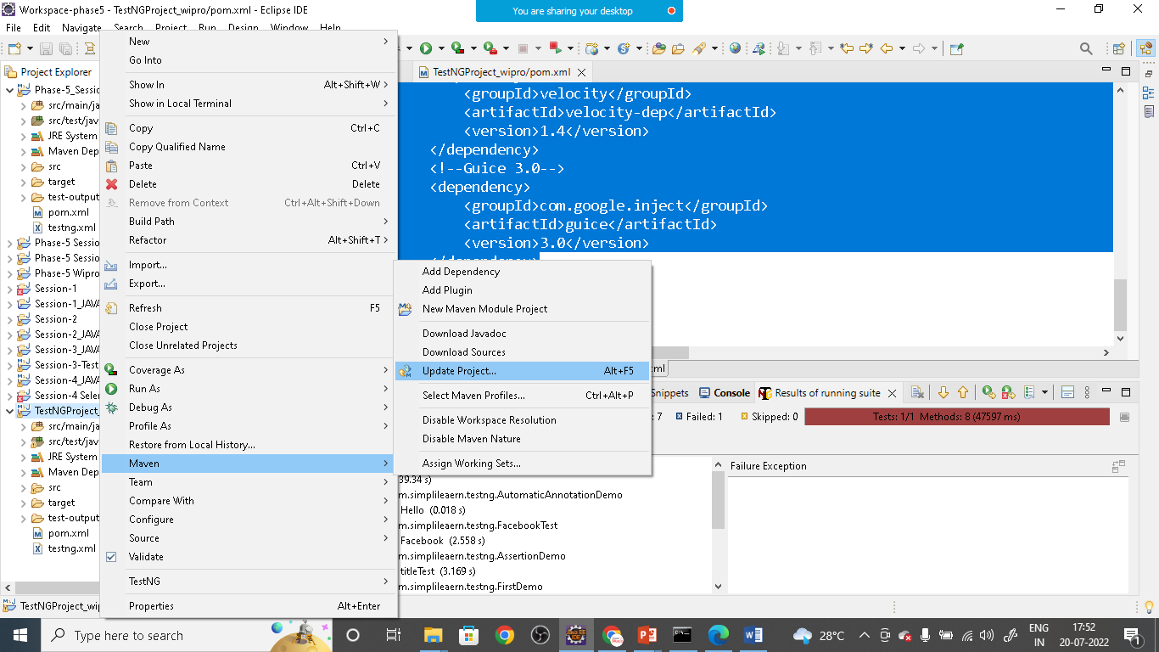

Once this is done

Now goto> testng.xml file and right click on it and run as TestNgSuit 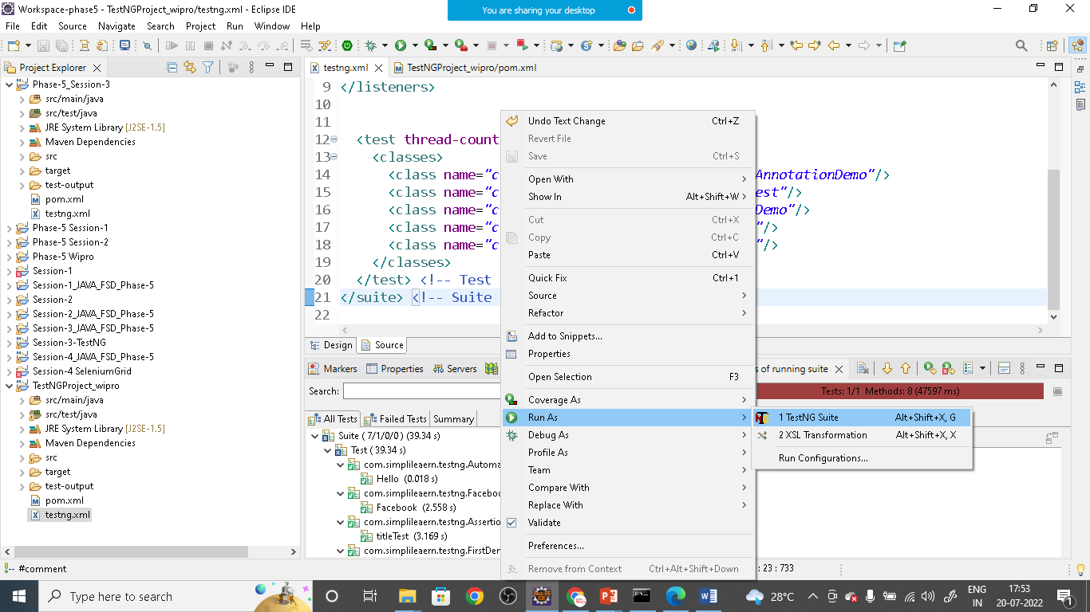

Once all test completed

Right click project and refresh the project

You will see one **test-out put** folder open

It has another folder **html** open it

You will see **index.html** file

Right click on it and open with default browser

